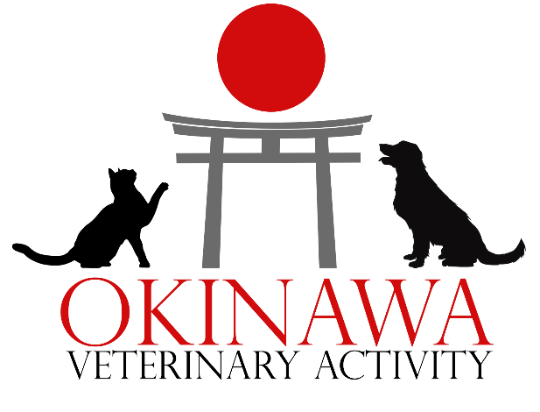
PCS CHECKLIST FOR PETS TO OCONUS LOCATIONS
EXCLUDING ALASKA, HAWAII, AND GUAM

- As soon as you have an assignment to an OCONUS location, please visit https://www.aphis.usda.gov/aphis/pet-travel/ for the most current import requirements for many countries. This step is critical to ensure that you are aware of and compliant with entry requirements to your destination.
- As a general rule, ensure your pet(s) vaccinations are current. Many countries may refuse entry for vaccinations administered within 21 days of entry. Some countries may require specific vaccinations, vaccination timelines, or vaccine titer tests prior to entering the country.
- Import permits may be required by your import destination or locations transited through. It is the responsibility of the owner to obtain these permits when required, prior to export.
- Obtain a bilingual or English original rabies certificate. You may also need original rabies certificates for prior vaccinations. Obtain an up-to-date vaccination record for your pet(s). If your pet(s) have been seen at a civilian veterinary clinic, you may want to obtain a copy of your pet(s) complete medical records.
- Contact the Okinawa VETAC as soon as you have the itinerary for your pet(s) flight to begin the process of scheduling the Health Certificate appointment.
- Obtain a copy of your pet(s) MDJ 270 if your pet was brought into Japan. This form is not required if your pet was born in and has never left Japan.
- Before your Health Certificate appointment can be scheduled, the Okinawa VETAC will need the following information:
  - Updated vaccination record if your pet received vaccines at a civilian clinic
  - Address or base at your final destination
  - How the pet will be traveling:
    - Owner traveling on the same plane as pet(s)
    - Designated person* traveling on the same plane as pet(s)
    - Pet transport company or airline cargo is solely responsible for shipping the pet AND the owner or designated person* has traveled or will travel within 5 days of the pet(s)
    - Neither the owner nor a designated person* is traveling within 5 days of the pet(s)
*Power of attorney must be provided in advance if one will be used. A designated person is a family member, friend, or other person authorized by the owner to travel with the pet(s).
- At your Health Certificate appointment, your pet will be examined by a veterinarian to assess whether the pet appears healthy enough for travel and verify that the pet is not showing signs of communicable disease. The veterinarian may also need to perform certain tests or administer medications during the appointment as required by the destination. The following documents will be issued from the Health Certificate appointment:
  - Health Certificate – Valid for 10 days of travel starting the date of the appointment. If your travel window exceeds 10 days, you will need more than one Health Certificate Exam. Please note that some countries have requirements that will reduce this travel time.
  - Letter of Acclimation – states that your pet is approved to fly by a veterinarian under certain conditions. It does not guarantee that your pet will be able to fly, as this will depend on the airline.
- After your pet(s) Health Certificate appointment:
  - Make copies of the following documents:
    - Health Certificate x 5
    - Letter of Acclimation x 5
    - Rabies Certificate x 5
    - Orders x 2
    - MDJ 270 x 2 (if applicable)
  - If flying commercially: You will need an appointment for an export inspection with Naha Animal Quarantine Service. Okinawa VETAC staff will coordinate this appointment to ensure that it works with your Health Certificate appointment.
  - If flying AMC: You may not need an export inspection appointment at Naha Animal Quarantine Service.
- The day before/day of flight:
  - Stop feeding 6-8 hours before the pet is due to fly.
  - Offer water before and in-flight (different airlines may have different requirements for this, be sure to look up the requirements for your flight).
  - Remove all pet accessories such as collars, leashes, toys, and clothes from the kennel and your pet, as these can present a choking hazard.
  - Line the bottom of the kennel with something soft and absorbent, such as a towel or soft blanket. Do not use excessive bedding.
  - Place copies of your documents inside a sealed zip lock bag and attach them to the top of the kennel. Retain all original documents and hand carry them.
IMPORTANT PHONE NUMBERS
Naha Quarantine Office, Okinawa 098-857-4468
Embassy of Japan, Washington DC 202-939-6700
USDA National Center, Import and Export, Maryland 301-734-8364
US Fish and Wildlife Service, Virginia 703-358-2104, ext. 5423
Okinawa Veterinary Activity
DSN: 315-630-3990
Email: usarmy.zama.phc-pacific.mbx.vra-j-okinawa-vetac@health.mil
Website: https://phcp.health.mil/Commands/Veterinary-Readiness-Activity-Japan/Okinawa/

